МИНИСТЕРСТВО НАУКИ И ВЫСШЕГО ОБРАЗОВАНИЯ РОССИЙСКОЙ ФЕДЕРАЦИИ
Федеральное государственное бюджетное образовательное учреждение
высшего образования
«Забайкальский государственный университет»
(ФГБОУ ВО «ЗабГУ»)
Факультет историко-филологический
Кафедра иностранных языков

УЧЕБНЫЕ МАТЕРИАЛЫ

для студентов заочной формы обучения
по дисциплине «Иностранный язык в профессиональной деятельности»

для направления подготовки (специальности)

13.04.01 Теплоэнергетика и теплотехника
Направленность ОП Технология производства электрической и тепловой энергии
составлена в соответствии с ФГОСВО, утвержденным приказом Министерства образования и науки Российской Федерации от
«28» февраля 2018г. 146

Общая трудоемкость дисциплины (модуля) составляет 6 зачетных(ые) единиц(ы), 216 часа.
Виды занятий | Распределение по семестрам |  |  | Всего часов
 | 1  семестр | 2  семестр | 3  семестр
1 | 2 | 3 | 4 | 5
Общая трудоемкость | 108 | 72 |  | 216
Аудиторные занятия, в т.ч.:
лекционные (ЛК)
практические (семинарские) (ПЗ, СЗ) | 8 | 8
лабораторные (ЛР)
Самостоятельная работа студентов (СРС) | 100 | 64
Форма промежуточной аттестации в семестре* | зачет | экзамен |  | 36
Курсовая работа (курсовой проект) (КР, КП)

Краткое содержание курса
№ п/п | Краткое содержание | Наименование оценочного материала
Первый семестр
1. | Виды инженерных профессий, роль инженера в обществе | диалог, перевод, сообщение / доклад
 | Найм на работу. Вакансии и опыт работы. Удовлетворенность работой. Тепловая энергетическая компания. Эффективность работы в инженерной компании | диалог, перевод, письменное творческое задание
 | Общение на рабочем месте. Корпоративная этика. Деловые встречи. Роль руководителя в организации. | диалог, перевод, сообщение / доклад
 | Контрольная точка предназначена для сдачи студентом учебного материала | контрольная работа
Второй семестр
2. | Тепловой насос. Двигатель внутреннего сгорания. Конъюгатный теплообмен и гидродинамика. Система работы теплового насоса. | перевод, сообщение / доклад, аннотации
 | Моделирование и имитация процессов. Модель генерации электроэнергии. Модель сжигания котла | перевод, реферат
 | Расчет энергетического баланса. Расчёт баланса электроэнергии | перевод, сообщение / доклад
 | Функционирование тепловой электростанции. Расчеты эффективности котлов и паровых турбин. Результаты системного анализа и уточнения. | перевод, реферат

Форма текущего контроля
МЕТОДИЧЕСКИЕ УКАЗАНИЯ
Особенностью овладения иностранным языком при заочном обучении является то, что объем самостоятельной работы студента по выработке речевых навыков и умений значительно превышает объем практических аудиторных занятий с преподавателем. Соотношение аудиторных и самостоятельных часов, отводимых на полный курс обучения равно 16 ч.: 164 ч. Таким образом, каждому аудиторному двухчасовому занятию должно предшествовать не менее шести часов самостоятельной работы студента.
Самостоятельная работа студента по изучению иностранного языка охватывает: заучивание слов профессиональной лексике на иностранном языке, повторение грамматических правил, чтение частично адаптированных и неадаптированных текстов на английском языке; построение вопросов и ответов к текстам; перевод на русский язык (устный и письменный).

ВЫПОЛНЕНИЕ КОНТРОЛЬНЫХ ЗАДАНИЙ И ОФОРМЛЕНИЕ КОНТРОЛЬНЫХ РАБОТ
1. Количество контрольных заданий, выполняемых вами на каждом курсе, устанавливается учебным планом вуза.
2. Каждое контрольное задание в данном пособии предлагается в трех вариантах. Вы должны выполнить один из трех вариантов в соответствии с последними цифрами студенческого шифра: студенты, шифр которых оканчивается на 1, 2 или 3, выполняют вариант № 1; на 4, 5 или 6 - № 2; на 7, 8, 9 или 0 - № 3.
В тех вузах, где нет системы шифра, кафедры иностранных языков указывают вариант, который студент должен выполнить. Все остальные варианты можно использовать в качестве материала для дополнительного чтения и для подготовки к экзамену.
3. Выполнять письменную контрольную работу следует в отдельной тетради.
4. Контрольные работы должны выполняться синими чернилами, аккуратно, четким почерком. При выполнении контрольной работы оставляйте в тетради широкие поля для замечаний, объяснений и методических указаний рецензента.
Материал контрольной работы следует располагать в тетради по следующему образцу:

Левая страница |  | Правая страница
Поля | Английский текст | Русский текст | Поля
5. Выполненные контрольные работы приносятся для проверки и рецензирования на первое практическое занятие в установленные сроки.
6. Если контрольная работа выполнена без соблюдения указаний или не полностью, она возвращается без проверки.
ИСПРАВЛЕНИЕ РАБОТЫ НА ОСНОВЕ РЕЦЕНЗИЙ
1. При получении от рецензента проверенной контрольной работы внимательно прочитайте рецензию, ознакомьтесь с замечаниями рецензента и проанализируйте отмеченные в работе ошибки.
2. Руководствуясь указаниями рецензента, проработайте еще раз учебный материал. Все предложения, в которых были обнаружены орфографические и грамматические ошибки или неточности перевода, перепишите начисто в исправленном виде в конце данной контрольной работы.
3. Только после того, как будут выполнены все указания рецензента и исправлены все ошибки, можно приступить к изучению материала очередного контрольного задания и его выполнению.
4. Отрецензированные контрольные работы являются учебными документами, которые необходимо сохранять и размещать в Личном кабинете студента на сайте вуза; помните о том, что во время зачета или экзамена производится проверка усвоения материала, вошедшею в контрольные работы.
ПОДГОТОВКА К ЭКЗАМЕНУ
В процессе подготовки к экзамену рекомендуется: а) повторно прочитать и перевести наиболее трудные тексты; б) просмотреть материал отрецензированных контрольных работ; в) проделать, выборочно отдельные упражнения из учебника для самопроверки; г) повторить материал для упражнений.
КОНТРОЛЬНОЕ ЗАДАНИЕ
(первый семестр)
Вариант 1

1. Warming up activity: answer the questions
1. What is engineering?
2. What do modern engineers produce?

3. What is the role of power thermal engineer in the society?
2. Match the words from the first column (1-9) with those from the second one (a-i).

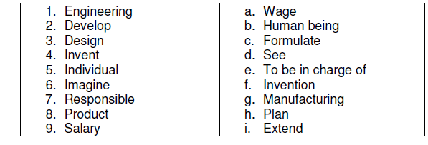
3. Tick the following sentences true (T) or false (F).
1. Engineering is the field of applying science and mathematics to develop solutions that have a practical end.
2. In a sense, engineers are not inventors.
3. They dream up ideas and make them a reality for the rest of us.
4. And as you can’t imagine, there is a great deal of prestige involved with being an engineer.
5. Engineers are in high demand in the corporate world and command fairly high salaries.

4. Complete the chart with noun forms

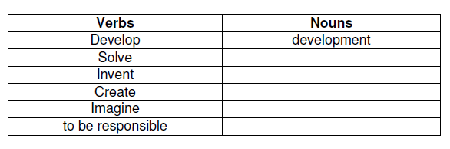
5. Complete these sentences. Use verbs and nouns from the chart. Make
sure you use the correct form of the verb.
E.G. Engineering development is highly demanded nowadays.
1. In order to make ____ you have to think properly.
2. ____ which are produced in TPU have a great success.
3. Innovation, ______ these are two points which characterize modern engineers.
4. _____ is one of the features, characterizing modern engineer.

5. The position of the engineer acquires______ imagination, invention.
6. Translate the following sentences.
1. Engineering is the field of applying science and mathematics.
2. Engineers design and manufacture machines, process, systems and even economical structures.
3. Engineers dream up ideas and make them a reality for the rest of us.
4. By utilizing science and math, engineers develop, improve the quality of life for society.

5. Engineers are often responsible for directly creating a new product or service.
7. Skim the text and entitle each paragraph. Make the written translation of the text
Engineering specialists
There are more than 25 recognized career tracks for the engineer. And you can rest assured that as technology advances, engineering specialties will only grow in number.
A few of the major engineering specialties include; aerospace, chemical, civil, electrical industrial, materials, mechanical, power thermal and software engineering. Learn a little about each specialty.
Aerospace engineers create aircraft and spacecraft. Aeronautical engineers are those that work with aircraft while astronautics engineers are those that work with spacecraft. Aerospace engineers also work with and develop satellites and missiles. As you can imagine, many are employed by the military and the government.
Chemical engineers usually manufacture products and design processes for chemical manufacturing. Therefore, chemical engineering requires an understanding of chemistry and even molecules and their interactions. Chemical engineers may specialize in a particular field or chemical process.
Civil engineers maintain and develop public transportation systems. They construct roads, bridges, dams, tunnels, airports and irrigation and sewage systems. They also create water treatment processes and test buildings. Civil engineering is one of the oldest engineering specialties.
Electrical engineering is one of the biggest engineering fields and includes all power systems, circuitry, microprocessors, computer chips, digital broadcasting and telephone switching systems. Electrical engineers traditionally focus on the generation and supply of power.
Industrial engineers create assembly line systems to help with manufacturing processes. They utilize energy, people, machines and information to help organize the manufacturing of a specific product. Industrial engineers must solve organizational problems and create an efficient production process. Many industrial engineers are in management positions. Materials engineers develop and test materials for creating products. This includes the development of ceramics, metals, plastics, glass and other materials. They help construct buildings, highways and manufactured goods from the materials.
Mechanical engineers are specialized engineers who work with mechanical devices. These may include elevators, refrigeration and air-conditioning equipment, robots and electric generators. Mechanical engineers design tools used in other engineering disciplines. As you can imagine, mechanical engineering is another one of the broadest engineering specialties. Learn more about a mechanical career.
Software engineering is also called web, IT engineering or software programming. Software engineers create programs for use on computer platforms or on the internet.
Power thermal engineers are engaged in producing boilers, reactors, some equipment which is widely used in modern industry. They design the projects of power thermal, nuclear stations.

Вариант 2
- Fill in the gaps, putting down the words in the correct form.
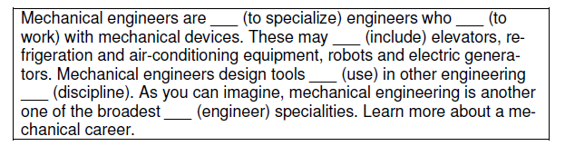
- What is the link between column A and column B?
- Match the words from the left column A to the right column B.
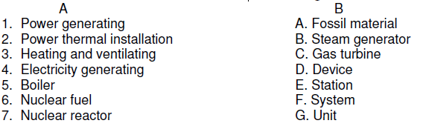
- Skim the text the information will help you to cover the tasks after it. Make the written translation of the text
EDUCATION REQUIREMENTS FOR ENGINEERS
The minimum requirements for becoming an engineer consist of a bachelor’s degree from a university accredited engineering program. A degree in engineering might go a long way, but it is also possible to become an engineer with a degree in math, physics or even computer science.
Keep in mind that there is quite a bit of math involved with most engineering programs or similar degrees. You can expect to take the following courses; algebra, geometry, trigonometry and calculus. You will also be expected to take a large variety of science coursework. Typical science courses for engineering majors include; biology, chemistry and physics. Depending on your area of emphasis, you may also need to take some computer programming or computer applications coursework. With the heavy course load involved in an engineering program, you should come prepared. Most university engineering programs require students to complete two years of high school algebra and one year of trigonometry for admissions. Engineering programs commonly require one year of both chemistry and physics for admissions as well.
After college, many engineering graduates choose to pursue a job. It is possible to graduate and start earning $40000 a year right out of college. A smaller subset of engineering graduates pursue in advanced degree in engineering (i.e. a Master's or Ph.D).
- Fill in the gaps in the sentences with the help of the words from the chart.
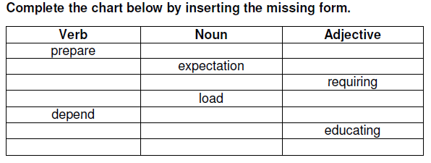
1. With the heavy course ___ involved in an engineering program, you should come ___.
2. Most university engineering programs ___ students to complete two years of high school.
3. It is possible ___ and start earning $40000 a year right out of college.
4. ___ your area of emphasis, you may also need to take some computer programming or computer applications coursework.
5. ___ requirements for engineers are given for every student in technical university.
6. List down the education requirements for engineers existing in a technical university

Вариант 3
- Match the words (1-9) from one column to the words (a-i) from the other column.
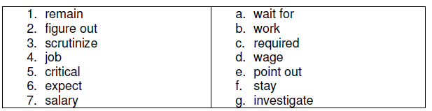
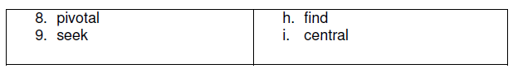
2. Fill in the gaps with the words from the brackets in a proper form.
1. Thermal Energy International Inc. is pleased to announce the _____ (establish) of ForEverGreen Energy Inc., a green energy services subsidiary.
2. Thermal Energy _____ (derive) revenues from the sale of assets.
3. The company _____ (provide) a further opportunity for customers to meet or exceed emission reduction _____(target) and achieve energy reduction targets.
4. Mr. Paradis, who has been retained by Thermal Energy business development and as project finance director has more than 40 years experience in start-up, development and management of major _____(engineer) and construction companies ____(provide) global services for design-build, finance and operation of projects.
3. Skim the text about Thermal Energy and extract the information about the company and its profile.
Thermal Energy International Inc. is an innovative technology company providing custom energy and emission reduction, and bioenergy solutions. Headquartered in Ottawa, Canada, TEI is a designer, design build developer, fabricator, owner, operator and supplier of proprietary and patented energy conservation, renewable energy and environmental technology solutions, and offers advanced process and applications engineering services. The Company is a proud member of the Chicago Climate Exchange. Company is a trademark of Thermal Energy International and is used under exclusive license from Gardner Energy Management Ltd.
4. Answer the questions about the text “Thermal energy”.
1. What is the thermal energy company?
2. Thermal energy is innovative technology company, isn’t it?
3. Is it situated in Canada?
4. The company is engaged in energy savings, emission reduction and bioenergy solutions, isn’t it?
5. Is Thermal Energy a fully accredited professional engineering firm? 6. Give some arguments to prove it.
5. Find the English equivalents to the following word-combinations:
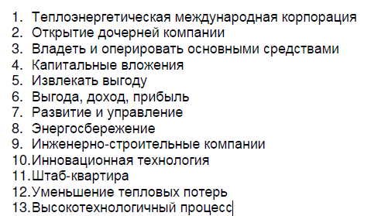
- Scan the text and find necessary information which suits to the power thermal engineering. Make the written translation of the text
DEPARTMENT OF THERMAL ENGINEERING AND DESALINATION
TECHNOLOGY
In the Kingdom of Saudi Arabia, the limited natural fresh water resources, the climatic conditions, the fast paced local industrial growth and the power generation to support desalination, air conditioning and industrial systems represent a major challenge, which thermal engineers have to face. This paved the way for establishing the Department of Thermal Engineering and Desalination Technology at King Abdulaziz University in Jeddah.
Thermal Engineering is a stimulating and very rewarding career in the field of Mechanical Engineering, with a large number of different pathways to be taken. It is however, a physically and emotionally demanding career, which needs to be entered into with care and thought after obtaining a realistic understanding of the skills of a thermal engineer, the conditions under which he works, the life style constraints of the profession and the necessary commitment to a lifetime of learning. The five-year Thermal Engineering and Desalination Technology program at King Abdulaziz University provides the knowledge, theoretical and practical skills, professional development and a commitment to lifelong learning, which enables a graduate to commence a career as a competent Mechanical Engineer.
The Department of Thermal Engineering and Desalination Technology offers a strong Mechanical Engineering Program with special emphasis on thermal applications such as refrigeration and air conditioning, desalination and energy conversion systems. These areas have been emphasized in appreciation of their importance for the life, comfort and development of the people of the Kingdom and the neighboring countries.
A dynamic curriculum revision and upgrading system consistent with the development of technology, the needs of the country and local industry has been established in the Department. As a result, the changes made in the current study plan in comparison with the old one reflect the emphasis on the above-mentioned issues. The current study plan has been devised to provide our students with a state of the art education and training to enable them as graduates to practice engineering in the 21st Century.
Much learning takes place in the laboratory, including industrial training settings. A major emphasis is placed on developing effective engineering communication skills, decision-making skills and on becoming competent users of engineering information and computing knowledge. Students are offered a common advice about how their studies are progressing and are also encouraged and advised on how to maximize their learning.
КОНТРОЛЬНОЕ ЗАДАНИЕ
(второй семестр)
Вариант 1
- Skim the text the information will help you to cover the tasks after it. Make the written translation of the text
Boiler
Two types of boilers are used in modern power plants: subcritical water-tube drum-type and supercritical once-through type. The former operates around 2500 psi, which is under the water critical pressure of 3208.2 psi. The latter operates above that pressure, at around 3500 psi. The superheated steam temperature is about 1000°F (540°C) because of turbine temperature limitations. A typical subcritical water-tube drum-type boiler has an inverted-U shape. On the bottom of the rising parties the furnace where the fuel is burned. The walls of the furnace are covered by water pipes. The drum and the super heater are at the top of the boiler. The falling part of the U houses the repeaters, economizer (water heater) and air preheater, which is supplied by the forced-draft fan. The induced-draft fan forces the flue gaseous of the system and sends them up the stack, which is located behind the boiler.
The steam generator has three major systems: fuel, air-flue gas and water-steam. Fuel is mixed with air and injected into the furnace through burners. The burners are equipped with nozzles, which are supplied by preheated air and carefully designed to assure the optimum air-fuel mix. The fuel mix is ignited by oil or gas torches. The furnace temperature is around 3000°F. Ambient air is driven by the forced-draft fan through the air preheater, which is heated by the high temperature (600°F) flue gases. The air is mixed with fuel in the burners and enters into the furnace, where it supports the fuel burning. The hot combustion flue gas generates steam and flows through the boiler to heat the super heater, reheaters, economizer etc. Induced-draft fans, located between the boiler and the stack, increase the flow and send the 300°F flue gases to the atmosphere through the stack.
- Read the text, entitle it and write the annotation
A power plant model developed based on a unit of a power plant in Central Queensland Australia. The power plant uses pulverised coal supplied through pulverisers and burnt in a boiler. The boiler of the plant is of the radiant tube type. It has natural circulation design with a low and high temperature economiser, a three-stage superheater and a two-stage single reheater. The boiler has a maximum steam outlet pressure of 16.2 MPa and a temperature of 541oC and feed water maximum temperature of 252o C.
The unit plant has a turbine to convert to convert thermal energy of steam into mechanical shaft rotation. The turbine has three pressure stages – high pressure, intermediate pressure and low pressure. In all three stages, there are stream extractors to facilitate regenerative heating of feed water heater. Three low-pressure heaters (LPH), one deaerator and two high pressure heaters (HPH) use bled steam for regenerative feed heating. A condenser is used in the power plant to condense low pressure steam into water. The condenser is water-cooled type and it has been built for seawater operation. There is a minor loss of water in the plant process. Therefore, makeup water for the boiler feed is added into the condenser hot-well after passing through a deaerating system. It has been found that the requirement for makeup water in the boiler is very low compared to the total requirement. The condensate passes through a series of heat exchangers - LPHs, deaerator and HPHs which take heat from the regenerative bled stream as mentioned earlier.
The highest capacity of the power plant is 280 MW of electrical power. This is the maximum capacity rating (MCR) of the power plant. The capacities of all individual process components were configured with appropriate data to produce the rated power.
- Write the report. Choose one of the topics. Be ready to speak on the topic and answer the questions
- The problems of heat exchange
- The work principle of a coal-fired power plant
- Processes of modeling and simulation used in thermal power engineering
Вариант 2
- Skim the text the information will help you to cover the tasks after it. Make the written translation of the text
Nuclear Power Plants
There are two main differences between a nuclear power plant and a fossil-fuel power plant: the first one uses nuclear fuel (uranium) instead of fossil fuel and it has a nuclear reactor instead of a boiler. In fact, it can have one or more nuclear reactors.
The fuel is placed in the reactor vessel filled with fluid. The fuel heats the fluid and the super-hot fluid goes to the steam generator. A steam generator is a heat exchanger used to convert water into steam from heat produced in the nuclear reactor. It can be 70 feet in height and weigh 800 tons. A steam generator includes a series of heat exchangers comprising tubes. The fluid heated in the reactor to the temperature of 250-300°C is delivered into the heat exchanger tubes. It is pumped under high pressure (up to 150 atmospheres), to prevent it from boiling. The fluid is highly radioactive, so it should never come into contact with the water which changes to steam. The water flows over the heat exchanger tubes where it heats and then evaporates.
The steam produced activates the steam turbine, the turbine in its turn drives the generator producing electricity. The nuclear reactor is cooled by water circulating through a system of tubes. A nuclear plant has a steam condenser in which the steam is condensed via cooled water and returned to the steam generator where it is heated once again. This is the most common way to extract usable energy from a controlled nuclear reaction.
Nuclear power plants have their advantages as well as disadvantages. The reactors and steam generators operate in them noiselessly; the atmosphere is not polluted by dust and smoke. As to the fuel consumption, it is of no special importance and there is no problem of fuel transportation.
The disadvantage of power plants utilizing nuclear fuel is their radiation. They are considered problematic for their safety and health risks. Radioactivity produced in the reactors is dangerous for the attending personnel. That is why the reactors and steam generators are installed underground. They are also shielded by thick (up to 1.5 m) concrete walls. All their controls are operated by means of automatic devices. These measures serve to protect people from radioactive radiation.
- Read the text, entitle it and write the annotation
The fundamental purpose of a deaerator in power generation is to remove oxygen and dissolved gases from boiler feed water. This helps prevent corrosion of metallic components from forming oxides or other chemical compounds. However, in the power generation model the deaerator was treated as a direct contact heat transfer component in order to describe it for the desired purpose of this study. In the deaerator, steam comes in direct contact with liquid water and therefore heat transfer occurs.
A tank model in SysCAD is a multipurpose model. There are sub-models available with a tank model such as reaction, environmental heat exchange, vapour liquid equilibrium, heat exchange, make-up, evaporation, and thermal split. It was used here for defining the deaerator. This tank model was configured to achieve vapour liquid equilibrium only. The other submodels were not used. The size of the deaerator tank was kept at 10 m3 and all the streams were brought to the lowest pressure through a built-in flashing mechanism.
- Write the report. Choose one of the topics. Be ready to speak on the topic and answer the questions
- The role of exergy in thermal power engineering
- Functionality of a thermal power plant
- Modern technologies of new and renewable energies

Вариант 3
- Skim the text the information will help you to cover the tasks after it. Make the written translation of the text
Blowers
Blowers may be divided into 2 types: 1) rotary and 2) centrifugal.
A common type of rotary blower is the Roots (рутсевский) two-lobe blower (вентилятор с двумя зубчатыми колесами). Two double lobe impellers mounted on parallel shaft connected by gears rotate in opposite directions and at the same speed. The impellers are machined to afford only a small clearance between them and between the casing and impellers. As the lobes revolve, air is drawn into the space between the impellers and the casing, where it is trapped (задерживается) and discharged in volumes equal to the space between the impellers and casing, and the operation is repeated four times for each rotation of the shaft.
In order to change the volume rate (обменный расход) of flow, the blower speed is changed. The pressure developed by the blower can force the air through the piping system. The volume of air delivered by the blower will not change. Thus the blower is called a positive-displacement blower (вентилятор с положительной подачей).
Care should be taken in operating any positive-displacement blower. A safety valve should be placed on the discharge line to prevent the discharge pres-sure becoming excessive. This valve will prevent overloading the discharge line and the driving motor. The advantages of the rotary blower are: 1) simple construction, 2) positive air movement, 3) economy of operation and low maintenance.
Centrifugal blowers and compressors operate on the same principle as centrifugal pumps and resemble the closed-impeller centrifugal pumps. The casing or housing is constructed of heavy steel plate, and the impeller is an aluminum-alloy casting. If care is taken in providing the proper drive motor, the overload characteristics of the centrifugal blowers will cause no trouble.

- Read the text, entitle it and write the annotation
In order to reduce emissions to the atmosphere, systematic research and development work on the existing electricity power plants for CO₂ capture are required. Research into CO₂ capture started two decades ago with both experimental investigations and numerical simulation methods. Lab-scale furnaces were initially used in order for researchers to identify and characterize the fundamentals and operations of oxy-fuel combustion issues under different operating conditions. The fundamental aspects of concern included, for example, flame stability, ignition behaviours, species concentrations, and fuel combustion rate. The heat transfer characteristics under different oxy-fuel-fired scenarios have been studied in order to reduce the retrofits needed to convert conventional boiler designs to oxy-combustion processes. Globally, there have been some studies on pilot-scale oxy-fuel combustion facilities in Europe and some developed countries. These investigations revealed that power plants can simply switch from air-fired combustion to the oxy firing at a large scale and produce higher concentrations of CO₂ in the flue gas. In addition, a significant reduction in NO_{x} emissions can be achieved due to eliminating N₂ from the oxy fuel combustion processes. These confirmations and support for oxy-fuel combustion technique for CO₂ capture show that there are no main crucial barriers in implementing this clean, efficient, and economic technology in industrial large-scale facilities. However, switching to oxy-combustion is completely dependent on public support and government developing policies to address global climate change.

- Write the report. Choose one of the topics. Be ready to speak on the topic and answer the questions
- Fundamentals and operations of oxy–fuel combustion power plants
- Boiler description and its operating conditions
- Selection and justification of technical solutions for heat exchanger modernization

